Set 21 — R Programs and Tableau Procedure
- Yaswanth [192324179]
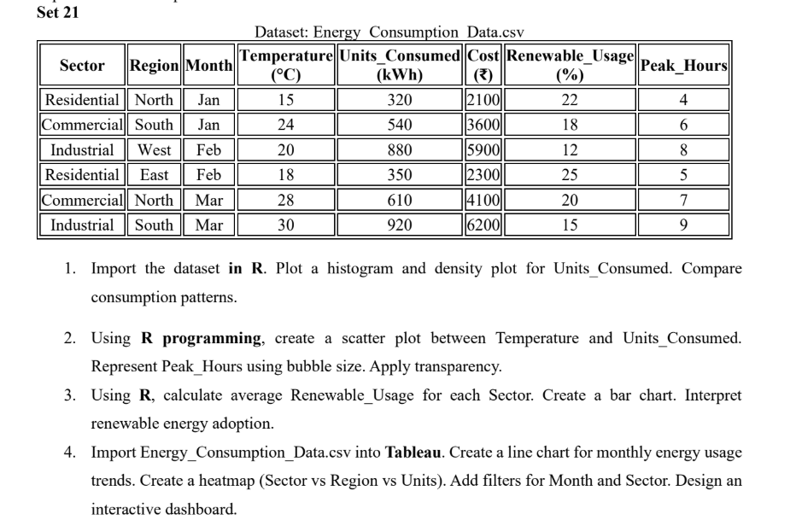
Question 1 — Histogram and Density Plot Using Temperature
Aim: To create a histogram and density curve to understand the distribution of temperature values.
R Code:
library(ggplot2)

energy <- data.frame(
Temperature = c(15, 24, 20, 18, 28, 30)
)

ggplot(energy, aes(x = Temperature)) +
geom_histogram(
aes(y = after_stat(density)),
bins = 5,
fill = "skyblue",
color = "black"
) +
geom_density(
color = "red",
linewidth = 1
) +
labs(
title = "Temperature Distribution",
x = "Temperature",
y = "Density"
) +
theme_minimal()

Output:
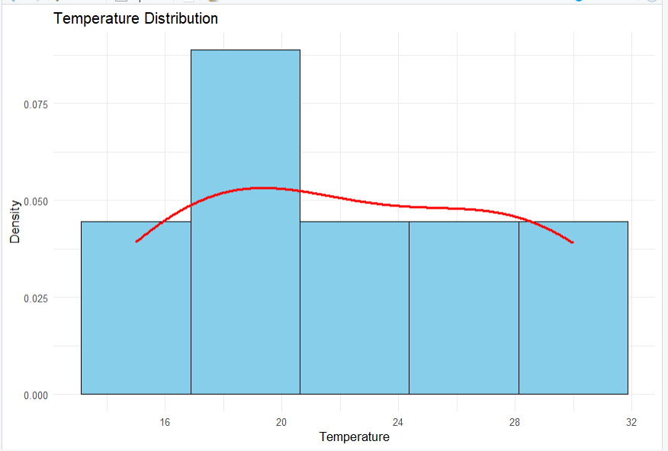

Question 2 — Bubble Chart of Energy Consumption
Aim: To compare energy consumption across sectors and regions, using bubble size to represent the units consumed.
R Code:
library(ggplot2)

energy <- data.frame(
Sector = c(
"Residential", "Commercial", "Industrial",
"Residential", "Commercial", "Industrial"
),
Region = c(
"North", "South", "West",
"East", "North", "South"
),
Units_Consumed = c(320, 540, 880, 350, 610, 920),
Cost = c(2100, 3600, 5900, 2300, 4100, 6200)
)

ggplot(
energy,
aes(
x = Units_Consumed,
y = Cost,
size = Units_Consumed,
color = Sector
)
) +
geom_point(alpha = 0.7) +
geom_text(
aes(label = Region),
vjust = -1,
size = 3
) +
labs(
title = "Energy Consumption by Sector and Region",
x = "Units Consumed",
y = "Cost",
size = "Units Consumed",
color = "Sector"
) +
theme_minimal()

Output:
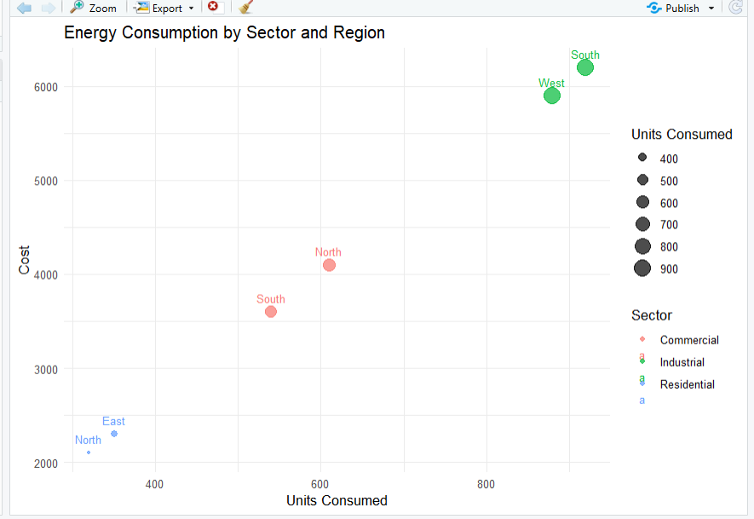

Question 3 — Average Renewable Usage by Sector
Aim: To calculate and visualize the average renewable usage for each sector.
R Code:
library(ggplot2)

energy <- data.frame(
Sector = c(
"Residential", "Commercial", "Industrial",
"Residential", "Commercial", "Industrial"
),
Renewable_Usage = c(22, 18, 12, 25, 20, 15)
)

average_usage <- aggregate(
Renewable_Usage ~ Sector,
data = energy,
FUN = mean
)

print(average_usage)

ggplot(
average_usage,
aes(x = Sector, y = Renewable_Usage, fill = Sector)
) +
geom_col() +
geom_text(
aes(label = round(Renewable_Usage, 2)),
vjust = -0.5
) +
labs(
title = "Average Renewable Usage by Sector",
x = "Sector",
y = "Average Renewable Usage"
) +
theme_minimal() +
theme(legend.position = "none")

Output:
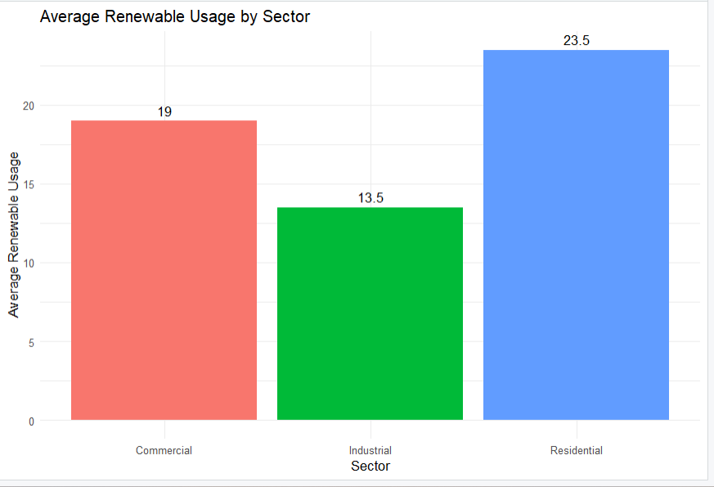

Question 4 — Energy Consumption Dashboard Using Tableau and R
Part A: Tableau procedure
- Enter the given energy consumption data in Excel and save it as Energy_Consumption_Data.xlsx.
- Open Tableau and connect to the Excel file.
- Create a line chart by dragging Month to Columns and Units_Consumed to Rows. Select the Line chart and ensure months are ordered Jan, Feb, Mar.
- Create a heatmap by dragging Sector to Rows and Region to Columns. Drag Units_Consumed to Color and Label, then select Square under Marks.
- Add Month and Sector as filters and select Show Filter.
- Create a new dashboard and name it Energy Consumption Analysis Dashboard.
- Drag the line chart and heatmap onto the dashboard.
- Arrange both charts, adjust titles and labels, and display the filters.
- If required, enable Use as Filter on a chart to filter the other chart interactively.
Output:
